**CCW Quoting Day1 KT1**

**1.CCW -cisco commerce workspace**

--Its like a web portal to order cisco products(like Amazon)

--End customers can't do it

--only internal users i.e., specific users can login and order it

**2.Quoting**

--Internal user will create a quote and there will be some base discount on those products

if End-Customer comes and asks us a cisco product.he can order on top of that quote

--quote mainly contains a product

--They are called SKU's or items and in technical terms we call it as "Quote Lines"

--In CCW quote is a part of CCW

--There are many modules in CCW.They are

a.quoting

b.ordering

c.Configuration

(config team will take care of configuring the items for a particular product)

(pricing team will take care about the discounts,list price etc whenevr we try to add item

--**unit list price**---ex:a mobile with MRP price(10,000)---"Unit List Price is 10,000/-"

--**Extended List price**--10 mobiles*List price(10*10,000)=1,00,000---"Extended List Price is 1,00,000/-"

--If we apply some base discount on that product then calculate that product price with discount--that is called "Unit Net Price"

and "Extended Net Price" also same like that

*unit list price is just for 1 quantity

*extended list price is for all 10 units

--So flow will be like "Quoting--Config--order

config and pricing--we will get inforamtion about items and prices form config and pricing

quoting-from quoting we create an order(based on this quoting we create an order)

**Overview**

1.login to the CCW

2.while quoting ,while adding items data cum config cum pricing

3.after we submit the quote

4.we can order on top of the quote

**Proxy: https://pdricw-cstg.cloudapps.cisco.com/ICW/PDR/proxyHome.do**

Loggin as sunchand/ cisco123 (Username/ pwd)

Proxy as “smadick”--partner

There are some fixed users who are authorized to login into CCW.They are 3 types of users

1.Partner

2.Distributor(disti)

3.Re-sellers

**1-tier flow:**

cisco-->partner(middleman)-->End-Customer================= "1-tier flow" ---quote will be fulfilled by "cisco"---cisco fullfillment

--partner gets items from cisco and sells the product to End-Customer

--later partner sends invoice to cisco i.e watevr billing is there from End-Customer partner will sends it to cisco

--cisco will not be involved in billing and all

--since we have one middleman here its called "1-tier flow"

**2-tier flow:**

cisco-->Disti-->Partner-->End-Customer============== "2-tier flow"--quote will be fulfilled by "disti"--disti fullfillment

--cisco can't have warehouses everywhere so distributors will have warehouses,they will buy products from cisco and stock them in warehouses

--And the partners,not only from cisco but they can buy products from distis also

**3.Re-sellers:**

Cisco-->Disti-->Re-sellers-->End-Customer==========="2-tier flow"

--there is no much difference between partner and reseller,the only thing is reseller can't directly buy product from cisco

--bcoz resellers will have small shops they directly sell products to end-customers

--where cisco cant directly can't reach out to end-customers

**Note:**

--when comes to partner,there are 2 ways

1.when partner buys product from cisco it is "1-tier flow"

2.when partner buys product from disti it is "2-tier flow"

====================

**Creating the quotes**

=====================

1.partner can create the quote either by 1-tier flow or 2-tier flow

2.disti can create the quote but when disti creates quote he has to mention the partner bcoz he cant sell the product directly to end-customers

so agin it is "2-tier flow"

3.There is another type of user called "AM(Account Manager)"

--these partners,distis,reseelres are all not part of cisco

--but these AM's are cisco employees(cisco team),they can also create quotes and sell directly to end-customers(again it is "1-tier flow")

--but the main difference is that they have more previlages and more functions that are enable for AM's

**In CCW**

--Another terminology that we use in CCW is "Deals And Quotes"

--Deal is a wrapper around the quote

--suppose we are introducing a product into a particular region,

--to promote that product in that region only, we will give some incentives and special discounts for that region only

--so if u want to have that special discouts in that particular region only,we create a Deal

--there will be 2 to 3 pages extra before quote creation

--Its like a wrapper.there is no difference between deal and quote

--incentives and questionaire will not be there for quote(for deal it will be there)

--partner if it is 2-tier(i.e using disti)cant able to determine the price.so distributor must determine the price i.e., the one (partner)

who is creating the quote will not be able to pay it

---this is basically a "Re-seller"

---so disti has to login into CCW and add the discounts and determine the price

Create deal

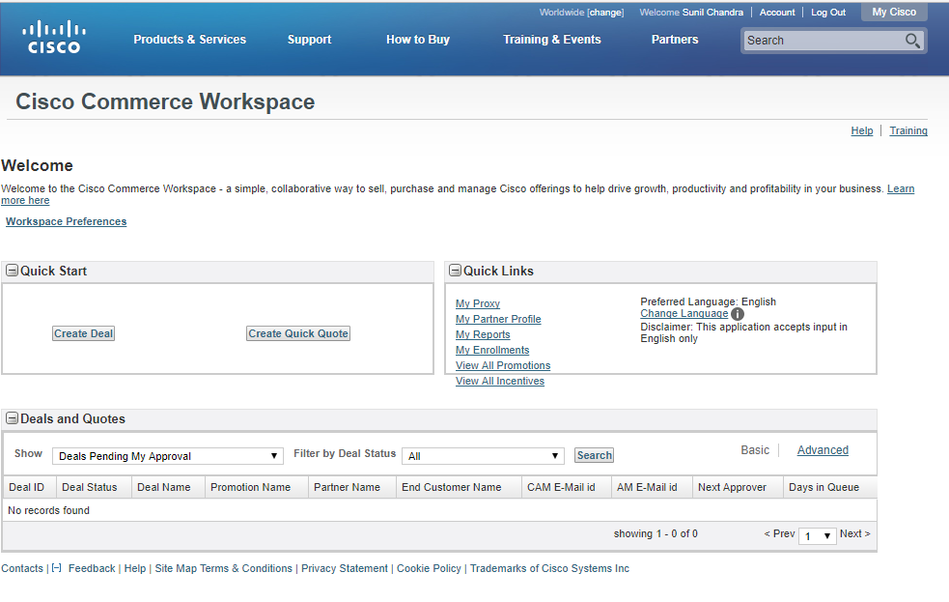

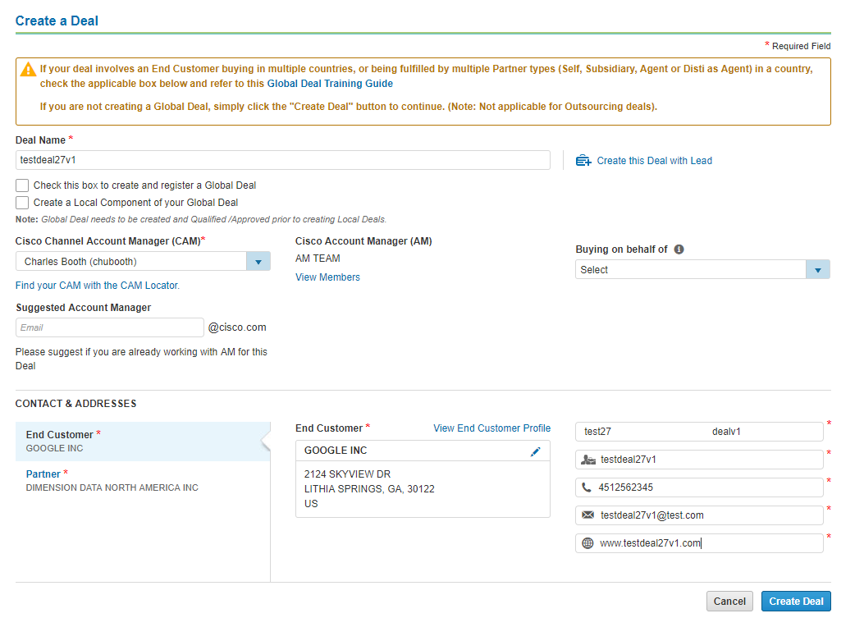

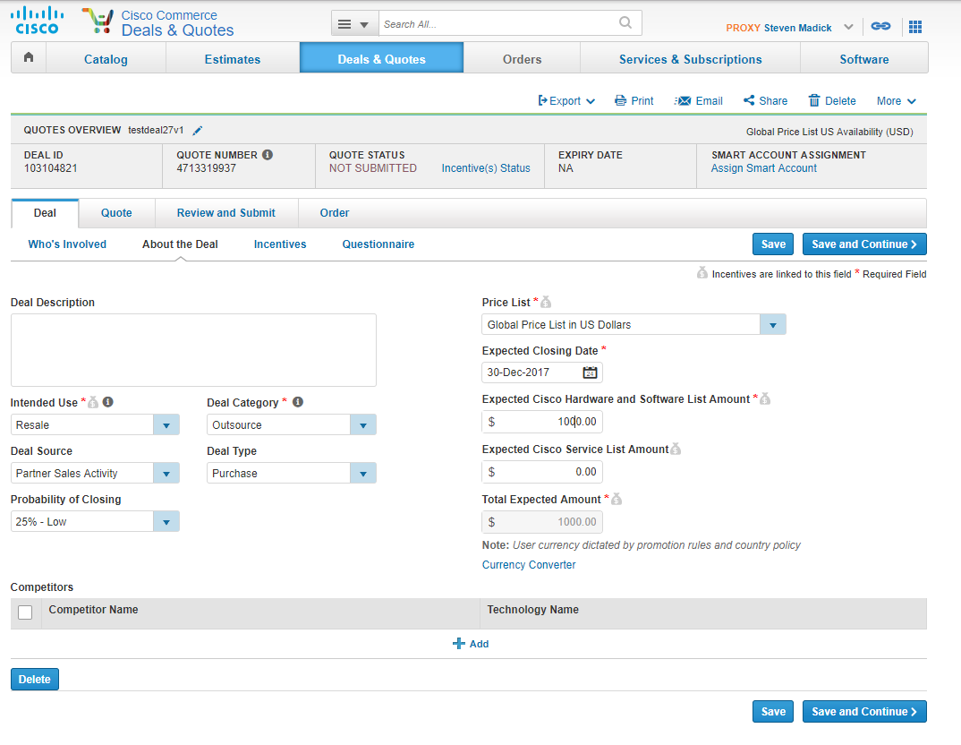

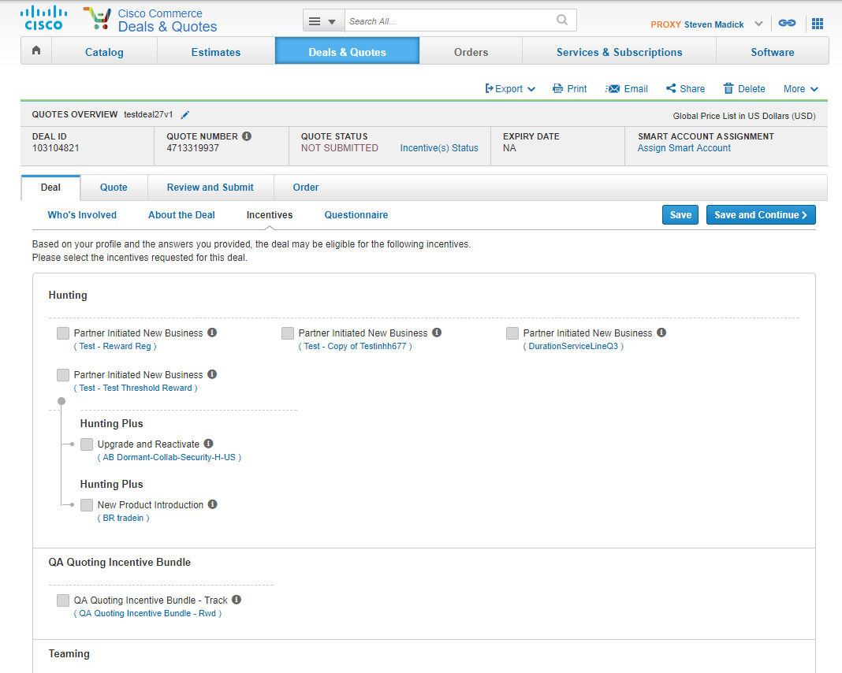

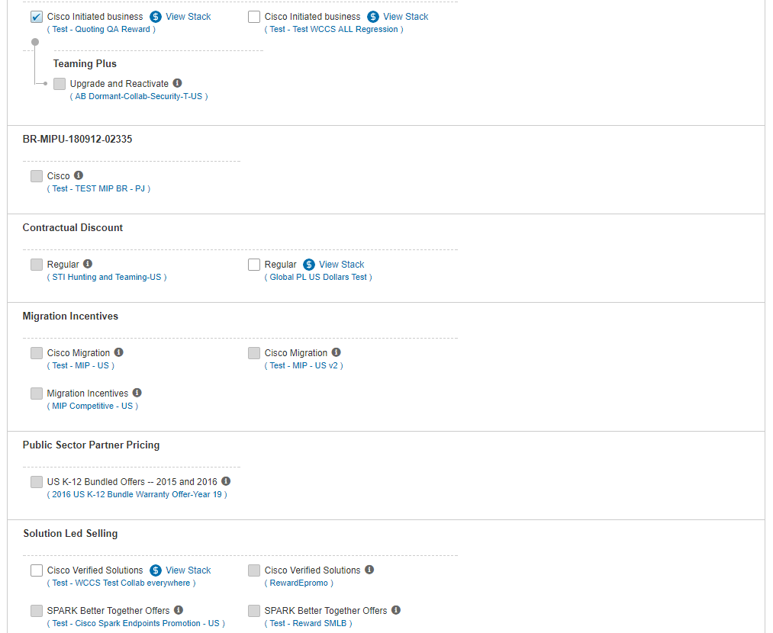

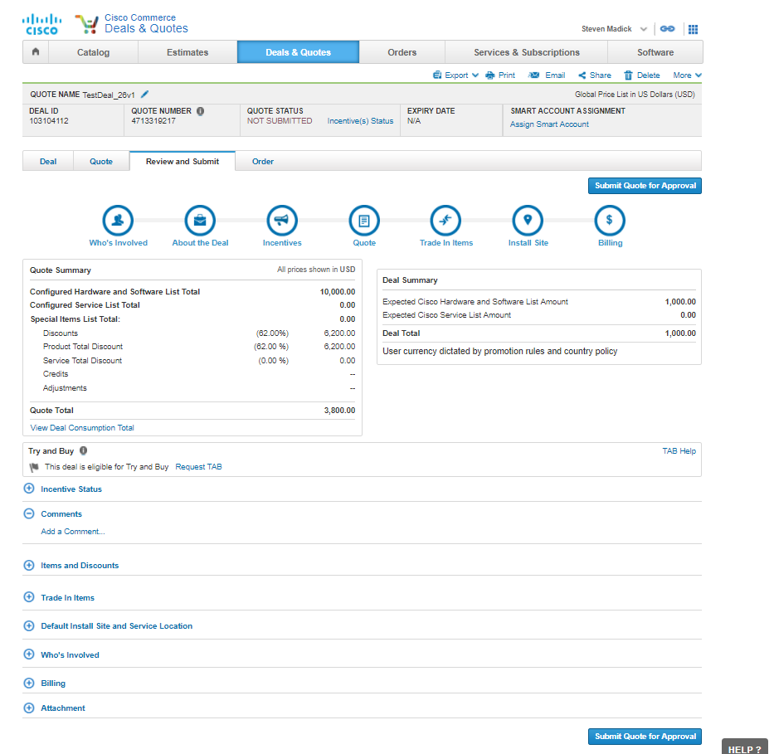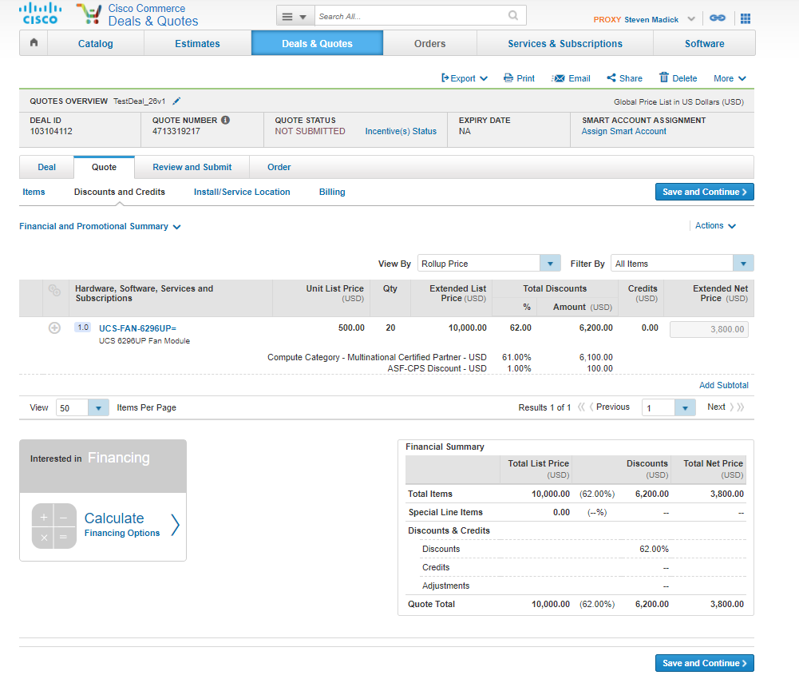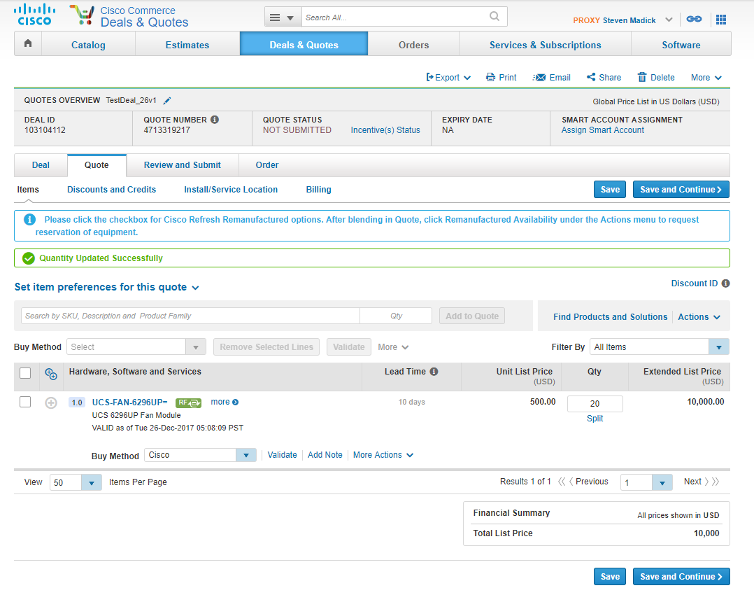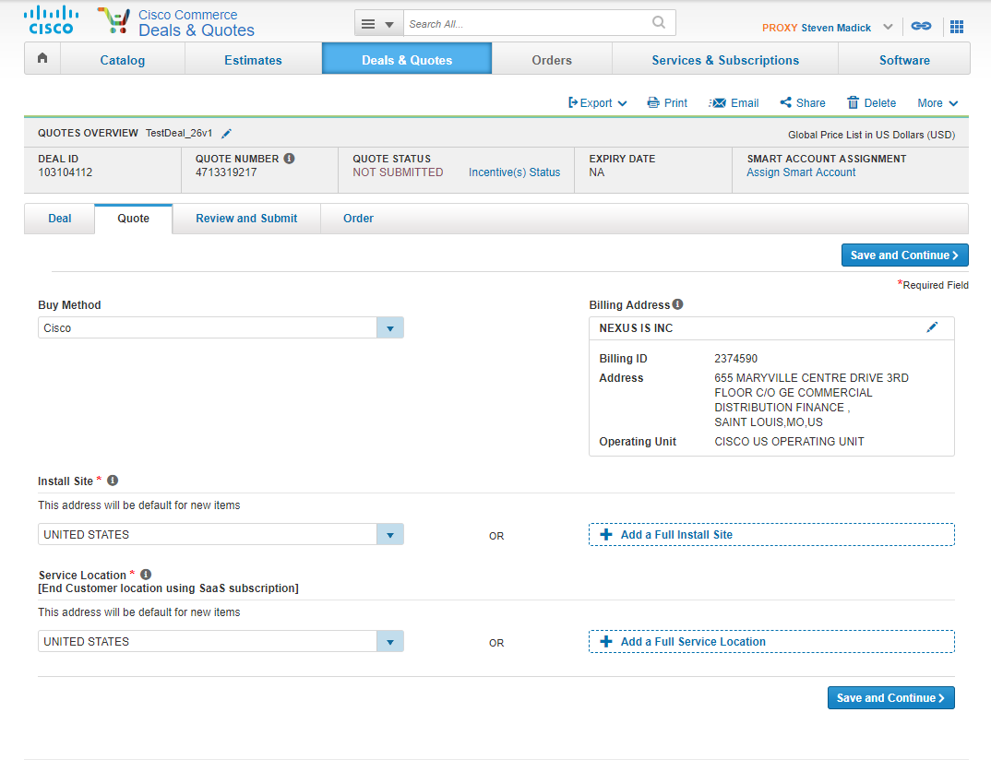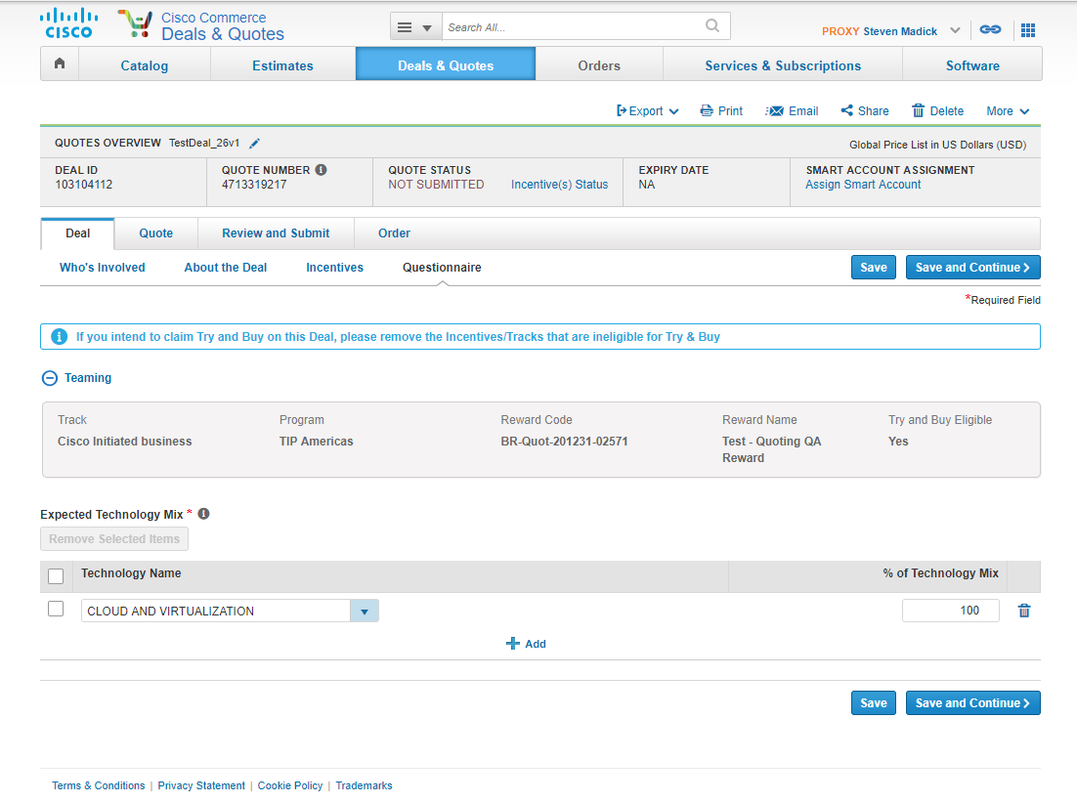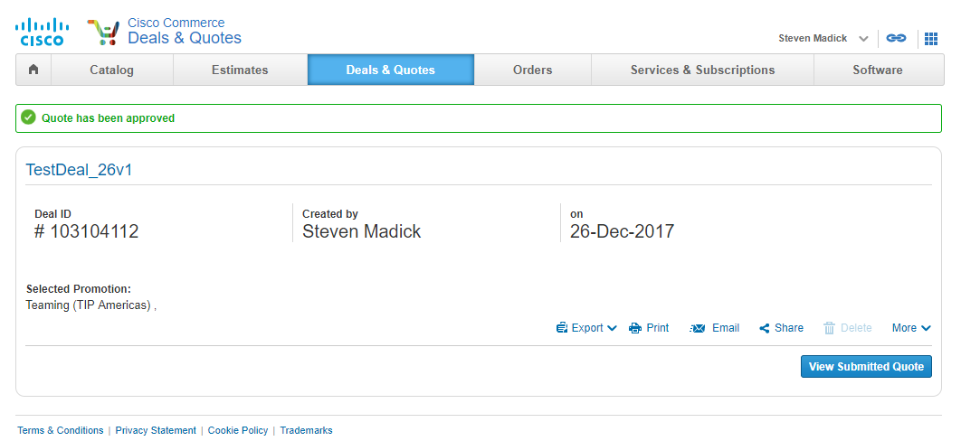

Create Quote

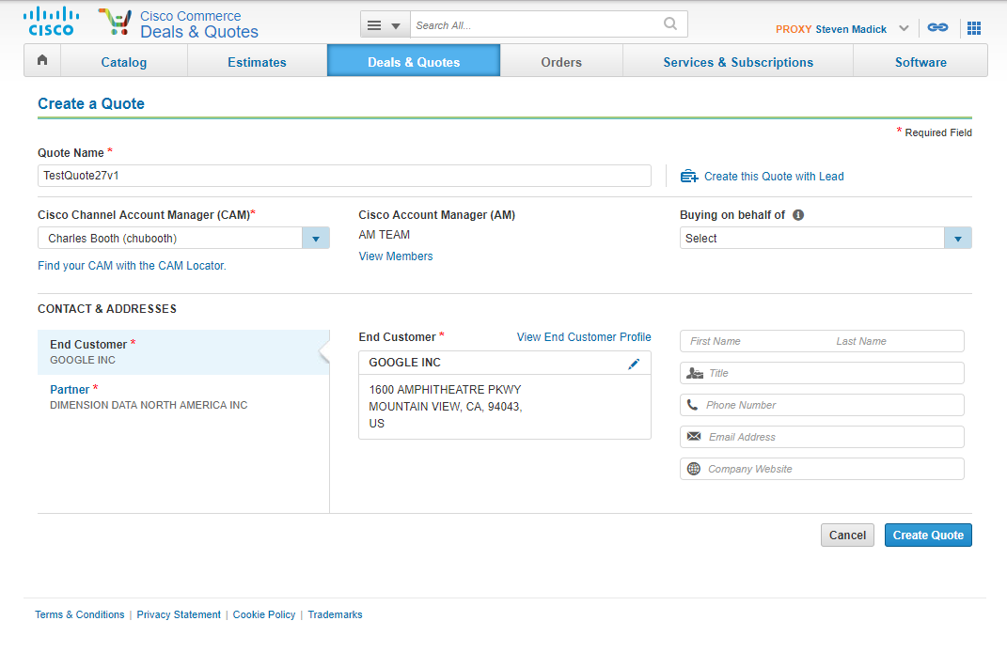

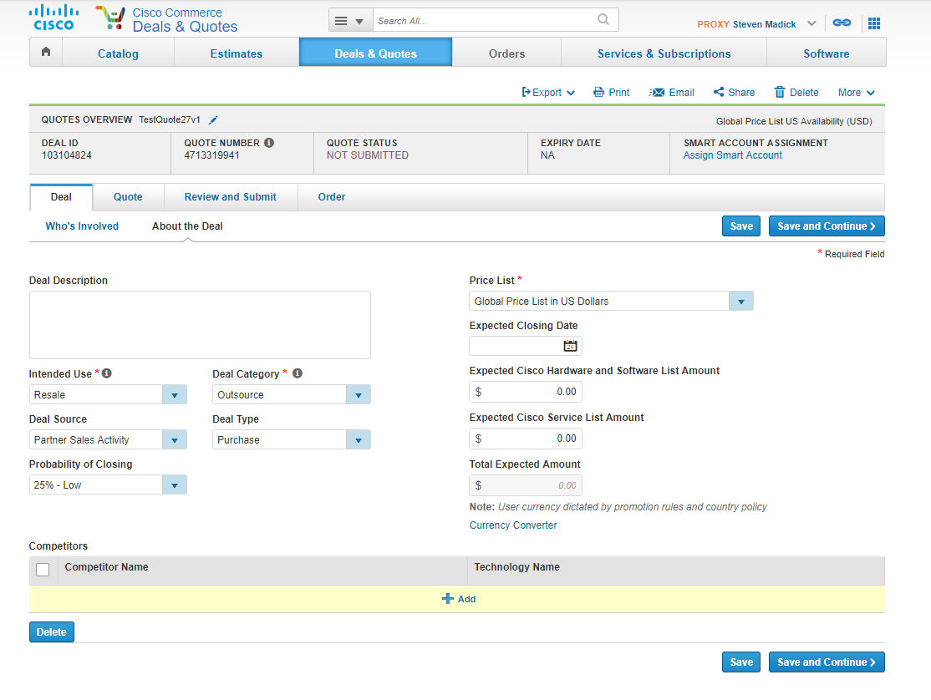

2-tier flow disti fulfillment (buy method disti)

